**Steel King Business Report**

**Research Question**

**Should Bakshi Ghura & Co. amend its pricing strategies to keep adequate liquidity for the smooth functioning of the business?**

July 2018

Research Proposal: 500

Executive Summary: 199

Written Report: 1998

**RESEARCH PROPOSAL**

**Research Question**

Should Bakshi Ghura & Co. amend its pricing strategies to keep adequate liquidity for the smooth functioning of the business?

**Proposed Methodology**

*Rationale*

**Bakshi Ghura & Co.** is a sole trader business that deals in trading Mild Steel Pipes. The company is a wholesaler and retailer of these pipes. It is based in Mumbai, India and was established in 1947. Since its foundation the business has been lucrative and is also one of the leading competitors in their market.

The business is profitable; however, it faces the central problem of cash flow, as proposed, that has to be ideal. With increased credit payments by customers, this situation is highly acceptable to tackle.

Therefore the research question is: **Should Bakshi Ghura & Co. amend its pricing strategies to keep adequate liquidity for the smooth functioning of the business?**

*Possible sources of information*

Primary Research

* Interviews with the owner

Advantage: Inside and personal knowledge is taken.

* Questionnaires prepared for the customers

Advantage: Information is gathered from the consumer’s perspective.

* Interviews with the accountant

Advantage: All aspects of financial information are gathered effectively.

Secondary Research

* Past and current years final accounts

Advantage: Financial analysis of the company is better by comparing it with past financial data.

* Websites of other companies and the Internet to collect information on the steel market and the country’s overall economic position.

Advantage: Evaluation of results would be enhanced due to comparisons made with other companies and the entire market as a whole.

*Organizations and individuals to be approached*

Organization - Bakshi Ghura & Co.

Owner of the firm – Mr. Bakshi Ghura, who will provide me with the primary data of the business. This includes his perspective of the current pricing strategies and the cash flow problem that he is facing.

Senior Manager – Mr. Deepak Shinde, who will assist me in providing his viewpoints on the pricing strategies used and the prospective solutions to them and the liquidity issue being faced by the business.

Financial Accountant – Mrs. Neeta Kelkar, who will aid with me in analyzing current and previous years’ financial accounts of the business.

Customers – Gather information from their viewpoint on the price of the products they have ordered and potential pricing strategies that can be employed.

*Methods to be used to collect and analyse data, and the reason for choosing them*

|  |  |  |
| --- | --- | --- |
| Methods for collecting data | Methods for analyzing data | Purpose |
| * Questionnaires * Interviews | * Force-field analysis * Profitability and Efficiency Ratios * SWOT Analysis | * Collecting primary data from the customers’ perspective about the pricing strategies employed and other possible strategies that could be applied. * Collecting financial secondary data from the financial accountant and analyzing and evaluating the efficiency ratios. * Collecting primary data from the Owner and Senior Manager on the company’s SWOT analysis as well as pricing strategies. |

*Anticipated Difficulties*

* Bias answers from interviewees

Possible Solution: Questions should be worded appropriately and a range of questions to be asked to eliminate as much bias as possible

* Linguistic problems could be faced during interviews/customers as English is not the first language of the staff and customers

Possible Solution: Avoiding jargon and stating the questions as clearly as possible to minimize misunderstandings.

* Limited source of secondary data about competitor strategies and overall market

Possible Solution: Depend more on primary research data collected.

*Order of activities and timescale of the project*

|  |  |  |
| --- | --- | --- |
| Date | Activity | Modifications |
| 1/7/16 | Selection of topic | The first chosen topic was focused mainly on only Finance, but this was then changed to Marketing as  well as Finance. |
| 5/7/16 | Research Proposal |  |
| 7/7/16 | Plan questions for interview with the owner of the business, senior manager, and  accountant. |  |
| 10/7/16 | Arrange a meeting to conduct  the interviews. |  |
| 15/7/16 | Conduct the interviews |  |
| 19/7/16  20/7/16 | Construct a questionnaire for the customers.  Distribute the questionnaire | The questions had to be translated to Hindi to make it convenient for the customers and, hence, the questionnaire had to be  redistributed. |
| 23/7/16 | Analyze the results of all  primary research done. |  |
| 25/7/16 | Conduct secondary research. |  |
| 29/7/16 | Rough Draft submitted |  |
| 30/7/16 | First Draft submitted |  |
| 31/7/16 | Final Draft submitted |  |

**Word Count - 500**

**Written Report**

**Title Page**

**Research Question**

**Should Bakshi Ghura & Co. amend its pricing strategies to keep adequate liquidity for the smooth functioning of the business?**

July 2018

Research Proposal: 500

Executive Summary: 199

Written Report: 1998

**Acknowledgement**

I would like to thank the Owner, Mr. Bakshi Ghura, the Financial Accountant, Mrs. Neeta Kelkar, as well as the Senior Manager, Mr. Deepak Shinde, for their assistance for providing data and allowing me to conduct research on their company. I am also thankful to the customers, who whole-heartedly filled in my questionnaires.

**Contents**

Title Page……….………………………………………………………………1

Acknowledgements……………………………………………………………..2

Research Proposal………………………………………………………………3

Contents Page…………………………………………………………………...7

Executive Summary (Abstract)…………………………………………………8

Introduction……………………………………………………………………..9

Research Question………………………………………………………………10

Methodology Employed………………………………………………………...11

Main Results and Findings……………………………………………………...12

1. Table 1: SWOT Analysis………………………..12
2. Efficiency Ratios………………………………...13
3. Figures 1 and 2…………………………………..15
4. Figures 3 and 4…………………………………..15
5. Figures 5 and 6…………………………………..16
6. Figures 7 and 8…………………………………..16
7. Figure 9…………………………………………..17
8. Figures 10 and 11………………………………...17

Analysis and Discussion………………………………………………………....18

Conclusion and Recommendation………………………………………………..22

References and Bibliography……………………………………………………..23

Appendices………………………………………………………………………..24

1. Appendix 1………………………………………..24
2. Appendix 2………………………………………..26
3. Appendix 3………………………………………..29
4. Appendix 4………………………………………..36
5. Appendix 5………………………………………..38

**Executive Summary**

**Bakshi Ghura & Co.** is a sole trader business that deals in trading Mild Steel Pipes.. The main issue is that of a poor working capital because of extended credit payments to the debtors, who are crossing the 60-day credit period. Thus, this investigation aims to answer the question:

*Should Bakshi Ghura & Co. amend its pricing strategies to keep adequate liquidity for the smooth functioning of the business?*

The methodology employed involved interviewing the Owner, Senior Manager and Financial Acoountant. A customer survey provided customers’ perspectives on Bakshi Ghura & Co’s. credit period, pricing strategy, and quality of pipes compared to that of its competitors. Secondary research involved finding the effects of external factors on the liquidity of the company and validating stakeholder claims.

Main findings indicate that Bakshi Ghura & Co. should not change its current short and long term pricing strategies to keep adequate liquidity. Analysis of this research was done through SWOT Analysis, Force Field Analysis and Efficiency Ratios. It was recommended that competitive and cost plus pricing was viable in order to remain competitive and reap profits, without hindering brand loyalty. It was concluded Bakshi Ghura & Co. do not change its pricing strategy.

Word Count - 199

**Introduction**

**Bakshi Ghura & Co.** is a sole trader business that deals in trading Mild Steel Pipes. The company is a wholesaler and retailer of these pipes. It is based in Mumbai, India and was established in 1947. Since its foundation, the business has been lucrative and is also one of the leading competitors in their market[1]. The business is profitable; however, it faces the central problem of cash flow, as proposed, that has to be ideal. Customers delay payments by asking for at least 30 to 60 days credit period[2]. Also, since bulk purchases are very frequent, more credit is asked on those purchases and the business’ working capital cycle worsens with every payment[3]. Tools such as SWOT, Force Field Analysis and Efficiency Ratios have been utilized to evaluate the best solution to solve the poor working capital issue. Therefore, keeping these issues in mind, my investigation would tackle these issues by focusing on the cash flow of the business as well as the pricing strategies employed. The company’s current and potential pricing strategies will be explored closely to see their effect on the cash flow of the business. The recent Demonetization Policy too has affected Bakshi Ghura & Co.’s working capital and, thus, the investigation aims to answer the **Research Question: Should Bakshi Ghura & Co. amend its pricing strategies to keep adequate liquidity for the smooth functioning of the business?**

**Research Question**

Should Bakshi Ghura & Co. amend its pricing strategies to keep adequate liquidity for the smooth functioning of the business?

**Methodology employed**

Primary research was successfully gathered through various stakeholders in the form of interviews and questionnaires.

The interview (Appendix 1) with the owner of the business was conducted to discuss about his perspectives on the current cash flow and working capital cycle position. His thoughts about the threats and weaknesses that the company’s financial department faced were also applied in evaluating the results. Also, the interview with the owner revealed that customers reported competitor strategies to him[4], which made him well informed about the pricing strategies being utilized in the market. Their data was also analyzed through a Force-field analysis.

The interview (Appendix 2) with the senior manager was conducted smoothly. Insight was given to me about the company’s customers and their attitudes towards the business. The risks and opportunities of employing different pricing strategies too were discussed and potential solutions to curb the working capital issue of the company. Hence, the Owner and Senior Manager interviews will be expressed through a SWOT Analysis of the business. Their data was also analyzed through a Force-field analysis.

The interview (Appendix 3) with the financial accountant provided extensive information on the company’s previous and current years Balance Sheets and Final Accounts. I collected two years’ balance sheet information for evaluating profitability as well as efficiency ratios for comparisons. The performance of the company was compared with past year accounts for better and unbiased evaluation.

A survey (Appendix 4) was provided to the customers to gain an understanding of their loyalty to the business and the current pricing strategy employed by the business. A total of 50 customers were questioned and their answers were recorded in the office. The questionnaire first sent caused confusion, as the customers did not understand the English language. Therefore, a new survey was sent to the Senior Manager and translated to Hindi to remove the language barriers. Anonymity was guaranteed to encourage honesty and to protect the customers. Their data was analyzed through a Force-field analysis.

Lastly, secondary research assisted me in finding multiple resources on the health of the economy and its effects on the steel industry. I also used the Internet to validate the stakeholders’ claims about the external environment.

**Main Results And Findings**

***Qualitative Findings***

Interview with the Owner and Senior Manager

The interview with these stakeholders provided me with Bakshi Ghura & Co.’s current position. The key points have been assembled into a SWOT Analysis.

|  |  |
| --- | --- |
| Strengths   * Brand loyalty because of the historically renowned image * Prime location fits customer’s ease of access * High quality pipes delivered to customers across the state * Internal growth of the business through starting two new brands selling the same good * Immense storage warehouse for durable pipes leads to meeting all the wants of customers. [5] | Weaknesses   * Delayed working capital cycle due to extended credit payments to debtors * High rate of absenteeism as well as labor turnover in the workplace * Overstocking leads to opportunity cost of spending the money on something fruitful, such as paying creditors[6] * Low net profit and gross profit margins in both years[7]. |
| Opportunities   * Due to steel rates rising, stock can be sold at better prices * Government has imposed safeguard duty on imports of steel[8] * Potential to increase customer awareness and loyalty * Potential to reap higher profits by cutting down unnecessary costs[9] | Threats   * Fierce competition with many established firms * Demonetization policy has led to increased credit payments * Customers fake information about other companies, leading to lower profits for the business as price is lowered [10] * Inflation has increased cost of raw material[11] |

Table 1: SWOT Analysis

The interview highlighted the effects of changing the pricing strategy on the business. The strengths above imply a sturdy foundation of the business in terms of customer satisfaction in quality of pipes, location of warehouse, loyalty and stock. The weaknesses represent the prime issue of liquidity faced by the business as well as other minor weaknesses that contribute to the worsening of the prime problem. The opportunities represent the external and internal factors beneficial for the business. Better steel rates, import duties, increased customer awareness and eliminating costs can lead to higher profits and, hence, a healthier economy and business. The threats signify mainly the ill effects of the current external environment. Intense competition, Demonetization, inflation and asymmetric information are a few elements.

***Quantitative Findings***

Interview with the Financial Accountant

This interview’s purpose was to collect information on the financial status of the company in the current and past one year. The information collected was through the firm’s Balance Sheets and Profit & Loss Accounts and then analyzed through efficiency, profitability and liquidity ratios.

* Profitability Ratios for the period 2014-2015:

Gross Profit Margin = [12]

Gross Profit Margin = $\frac{4782819.91}{69033139.10}×100$ = 6.93% (3 significant figures)

Net Profit Margin = [13]

Net Profit Margin = $\frac{1338099.73}{69033139.10}×100$ = 1.94% (3 significant figures)

* Profitability Ratios for the period 2015-2016:

Gross Profit Margin = $\frac{4290470.52}{60944845.60}×100=$ 7.04% (3 significant figures)

Net Profit Margin = $\frac{1560976.77}{60944845.60}×100$ = 2.56% (3 significant figures)

* Efficiency Ratios for the period 2014 – 2015:

Creditor Days = $\frac{Creditors}{Cost of Goods Sold}×365$

Creditor Days = $\frac{15543482.84}{64,250,319.19}×365=88.3=88 days$

Debtor Days = $\frac{Debtors}{Sales Revenue}×365$

Debtor Days = $\frac{11617491.00}{69033139.10}×365=61.4=61 days$

* Efficiency Ratios for the period 2015 – 2016:

Creditor Days = $\frac{10994537.84}{56654375.00}×365=70.8=71 days$

Debtor Days = $\frac{140322691.00}{60944845.6}×365=$ 84.0 = 84 days

* Liquidity Ratios for the period 2014 – 2015:

Current Ratio = [14]

Current Ratio = $\frac{32516861.88}{15910912.84}$ = 2.04:1 (3 significant figures)

Acid Test Ratio = [15]

Acid Test Ratio = $\frac{32516861.88-16611875.08}{15910912.84}$ = 1.00:1 (3 significant figures)

* Liquidity Ratios for the period 2015– 2016:

Current Ratio = $\frac{40777031.40}{11341873.84}$ = 3.60:1 (3 significant figures)

Acid Test Ratio = $\frac{40777031.40-10200642.00}{11341873.84}$ = 2.70:1 (3 significant figures)

Figure 1 and 2: Customer survey on the quality of pipes of Bakshi Ghura & Co. vs Competitors[16]

**vs**

Figure 3 and 4: Customer survey on the current price of pipes ofBakshi Ghura & Co. vs Competitors[17]

**vs**

Figure 5 and 6: Customer survey on discount or incentive given by Bakshi Ghura & Co. vs Competitors[18]

**vs**

Figure 7 and 8: Customer survey on the sufficiency of credit period provided byBakshi Ghura & Co. vs Competitors[19]

**vs**

Figure 9: Customer survey on the credit period comparison of Competitors with Bakshi Ghura & Co.[20]

Figure 10 and 11: Customer survey on why and how many times pipes are purchased from Bakshi Ghura & Co. rather than from competitors[21].

**Analysis and Discussion**

SWOT analysis is a process that identifies the strengths, weaknesses, opportunities and threats of an organization. Specifically, SWOT is a basic, analytical framework that assesses what an organization can and cannot do, as well as its potential opportunities and threats.[22] Force Field Analysis deals with the forces for and against change. Driving forces are the benefits of change whilst restraining forces are the causes of resistance to change[23].

The SWOT analysis, Force-field analysis and Efficiency Ratios calculated can be utilized to solve the current problem.

**Price Skimming:**

Figure 12: Force Field Analysis for Price Skimming

Driving Forces

Restraining Forces

Change:

Should Bakshi Ghura & Co. change its pricing strategy to price skimming?

Very fierce competition and many established competitors

Quality of pipes superior to competitors

4

4

Brand loyalty and trust

4

Delay of credit payments due to increased cost to consumers

4

Bakshi Ghura & Co. is renowned for low prices

3

8

11

According to the Owner and customers, the quality of Bakshi Ghura & Co’s. pipes have been excellent. This is supported by statistical data in Figure 1, which states that 34 out of the 50 customers of Bakshi Ghura & Co. feel that their pipes have excellent quality and 16 out of the 50 feel that they have good quality pipes. On the other hand, 31 customers feel that competitor pipes have excellent pipes, 14 customers feel they have good pipes and 5 customers feel they have moderate quality pipes[24]. This proves how superior and trusted Bakshi Ghura & Co’s. pipes are compared to those of its competitors. In terms of the pricing strategy, Bakshi Ghura & Co. should be able to sell its pipes at a higher price because of the high quality it offers. However, the Senior Manager, customer survey and profitability as well as liquidity ratios refute this.

Competition is fierce in the market and there are clearly many substitutes to buy steel pipes from[25]. Mostly, the competitors use low prices and competitive pricing. It is very rare that a business in this market would employ prices higher than the market equilibrium price. Also, according to the customer survey, customers feel that the prices offered by Bakshi Ghura & Co. are more competitive and lower than its competitors. Figure 1 and 2 represent this as price of pipes offered by Bakshi Ghura & Co. are lower (12 customers) than those offered by competitors. Not only this, but also Figure 10 and 11 prove that price skimming wouldn’t be beneficial. The business has many loyal customers, as said by the owner and shown by Figure 11 (28 customers always buy from Bakshi Ghura & Co.). These customers mainly do not buy from substitutes because of the lower price offered (18 customers feel they are loyal because the business offers low prices), as seen in Figure 10. More customers feel that increasing prices would mean losing out on loyal and potential customers because the business is renowned for offering low prices and discounts.

From the consumers’ perspective, price skimming would delay credit payments as well. Debtor days increased from 61 days, in 2015, to 84 days, in 2016. Increase in price would take customers longer to pay, disrupting the working capital cycle. Also, Demonetization has heavily affected the increase of debtor days in 2016.

Therefore, price skimming in the long-run would not yield any profits or improve the current ratio for the business.

**Penetration Pricing:**

Figure 13: Force Field Analysis for Penetration Pricing

Driving Forces

Restraining Forces

Change:

Should Bakshi Ghura & Co. change its pricing strategy to penetration pricing?

The business is already very well established

Bakshi Ghura & Co.’s credit period is more sufficient than competitors

4

4

The pipes quality may be seen as inferior

Gross and Net profit margins have increased over the last year

4

3

Bakshi Ghura & Co. gives more discount or incentive compared to that of competitors

Long-run profits aren’t guaranteed as cash inflows may suffer

3

3

Under stocking may lead to dissatisfied customers

Best possible strategy in a financial crisis (external or internal) business.

3

2

14

12

According to Figures 7 and 8, customers feel that the credit period offered by Bakshi Ghura & Co. is more sufficient than that of its competitors. Employing Penetration pricing would mean that consumers pay off their debt quicker than the current period, as the cost to buy pipes decreases. Therefore, cash inflows would enter the business at an earlier period, improving the business’ working capital cycle.

Gross profit margin increased from 6.93%, in 2015, to 7.04%, in 2016, and Net profit margin increased from 1.94%, in 2015, to 2.56%, in 2016. This increase implies better efficiency in terms of cost cutting. Penetration pricing reinforces cost efficiency, as the emphasis is on keeping the price low, which helps in controlling cost.

Figure 5, compared to Figure 6, shows that customers feel Bakshi Ghura & Co. offer more discounts than its competitors. This creates an advantage for Penetration pricing as prices are already kept low, which creates the notion of a discounted price in the consumers’ minds. They would, therefore, be attracted and get lured into buying at a very low price.

The Senior Manager feels that Penetration Pricing is effective in financial crises too. In a recession (external crisis), low prices can be beneficial for customers as their incomes are kept low and consumption decreases. Therefore, a low price rather than a high price would lure them again to buying it.

Most of the restraining forces act as counter-intuitive to Penetration pricing. This strategy is mainly used to establish or penetrate a business in a competitive market. However, the business is already a leading competitor in the market. Also, quality and price are complementary. High price pipes might be looked at as premium quality. Figures 1 and 2 show that customers feel that Bakshi Ghura & Co’s. pipes are of better quality than those of competitors. Therefore, a low price may be seen as low quality pipes.

Although, cash inflows may enter the business on time, the cash sales may suffer due to lower price. Sales revenue may be jeopardized as a result of low price. Therefore, long-term profits could be harmed if Bakshi Ghura & Co. doesn’t keep their costs low.

Lastly, because steel pipes are elastic goods, demand may increase if price is lowered. An increase in demand would mean an increase in stock turnover. This can lead to under stocking, which can inhibit customer dissatisfaction. Moreover, staff turnover is high; hence, under stocking could become a major issue for the business.

Therefore, Penetration pricing too isn’t a viable solution for both, the long and short run.

**Conclusion(s)**

The research has investigated Bakshi Ghura & Co. liquidity issue and how it could be improved through amending its pricing strategies.

It can be concluded that Bakshi Ghura & Co. do not make amends to their current pricing strategies of competitive pricing, in the short-run, and cost-plus pricing, in the long-run. It will enable them to get sufficient cash inflows at a suitable time period (mostly in 60 days), which is an ideal credit period.

**Area of Further Investigation**

Limitations too are present in this investigation, such as limited sources of information, the impact of the external environment, and limited business tools. All of these factors would have affected the conclusion and recommendation. Bakshi Ghura & Co. should consider further research through employing more tools and sources of information.

**Recommendation(s)**

From the results shown, the following recommendations should be considered in tackling the liquidity crisis of Bakshi Ghura & Co.

* The Force Field Analysis proves that none of the potential pricing strategies, Penetration pricing and Price Skimming, should be implemented.
* A mix of Competitive Pricing, in the short-run, and Cost-plus Pricing, in the long-run, should be employed in order to keep customer credit period ideal and also safeguard the business from external threats.
* Along with current pricing strategies, other methods of tackling increased customer credit are:

1. Tighter credit controls to receive cash sooner and improve cash flow.
2. Negotiating credit periods with suppliers to increase Creditor Days for better cash outflow and, hence, working capital.
3. Providing discounts and incentives to customers to pay credit payments on time (within the 60 day range).

**References and Bibliography**

Books

Hoang, Paul. *International baccalaureate business and management*. Place of publication not identified: Ibid Press, 2014. Print.

Interviews

Ghura, Bakshi, Mr. "Interview with the Owner (Mr. Bakshi Ghura)." Interview. 20 June 2016: n. pag. Web. 20 June 2016.

Shinde, Deepak, Mr. "Interview with the Senior Manager (Mr. Deepak Shinde)." Personal interview. 15 June 2016.

Kelkar, Neeta, Mrs. "Interview conducted with the Financial Accountant (Mrs. Neeta Kelkar)." Personal interview. 15 June 2016.

Questionnaires

"Survey/Questionnaire for the customers." Personal interview. 15 June 2016.

Internet

Root. "SWOT Analysis." *Investopedia*. N.p., 13 Oct. 2015. Web. 30 Sept. 2017. <<http://www.investopedia.com/terms/s/swot.asp>>

"How Will Demonetization Affect Business in India in 2017?" *Knowledge@Wharton*. N.p., n.d. Web. 10 Nov. 2016. <http://knowledge.wharton.upenn.edu/article/will-demonetization-affect-business-india-2017/>

**Appendices**

**Appendix 1: Interview with the Owner (Mr. Bakshi Ghura)**

|  |  |
| --- | --- |
| What is the business about? Where does retail and wholesale take place? Size? Industry? On a scale of 1-5, how established and competitive is the business? Location? | Bakshi Ghura & Co. is a sole trader business. We retail and wholesale mild steel pipes all across the Maharashtra state and are one of the leading competitors of the steel market. The steel industry is currently facing slow growth.  Our business was established in 1947, and since then we have had loyal customers buying from us. I would rate it a 4 on 5. We have also internally grown by launching two brands of retail in 2010.  Our warehouse and office are in the same prime location of Mumbai. Hence, it is convenient for customers to transport to our office. |
| How important is customer satisfaction to you and is the business meeting customer requirement on time?  How would you rate quality of your pipes out of 5?  How would you rate affordability of the low prices of pipes out of 5? | Being customer-centric and ensuring profits is the main motive of the business.  We trust our suppliers in providing us high quality pipes at a discounted rate. Therefore, quality is not compromised with high price. I would rate quality a 4 out of 5. It is affordable for all. You could say, we use a competitive pricing strategy and also provide discounts to regular customers. I would rate affordability of our low prices a 3 because of intense competition and low prices offered by other businesses too. Our credit period payment to suppliers is between 60 to 90 days.  Our warehouse storage is huge and, as a result, we can easily meet customer requirements by providing them the right size of pipe. |
| How fierce is competition in the market? How would you rate competition out of 5? What pricing strategies do competitors employ?  You said about devoted customers. How would you rate brand loyalty out of 5? | Competition is very fierce in the market and I would rate it 4 out of 5. There are many established firms, like us, in the market and are lucrative as well. They too have loyal customers buying from them.  It is very difficult for us to know about competitor tactics and actions. Therefore, we use our devoted customers as a way to tell us about other competitor information. Mostly our competitors use low prices and competitive pricing. It is very rare that a business would employ prices higher than the market equilibrium price, which is determined by steel rates.  I would rate brand loyalty a 4 out of 5. |
| What is the main issue being faced by the business? How would you rate the concern of the issue at hand out of 5? What are other minor issues that hinder business performance?  On a scale of 1-5, how much would you rate the under stocking issue? | The main issue is that of a poor working capital because of extended credit payments to our debtors. Our business mainly gets bulk purchase orders. As a result, we need to provide discounts and extended credit period for our customers. Generally, we give a 60-day credit period to our customers. It is a way of enticing them to become loyal customers. To make matters worse, the Demonetization Policy of the government has led to increased credit time for payment, worsening the working capital cycle. I would rate it a 4 out of 5.  At times, we overstock because of uncertainty in the market and that adds to extra costs. The extra costs could be used in other productive means, such as paying creditors.  High staff turnover too is a problem in the warehouse. This can lead to under stocking of our pipes, as the right employees are not present at the right time, and, hence, not all customer requirements are met.  I would rate it a 3 out of 5. |

**Appendix 2: Interview with the Senior Manager (Mr. Deepak Shinde)**

|  |  |
| --- | --- |
| I am currently aware of the working capital issue faced by the business. I would like to know more about the various pricing strategies that can be employed by the business to curb this issue. What short-term and long-term effects will these pricing strategies have on the consumers and on the business?  You spoke about your quality of pipes being inferior to those of competitors due to Penetration pricing. On a scale of 1-5, how inferior will pipes be?  You also spoke about long-run profits and cash inflows. How would you rate this disadvantage on a scale of 1-5?  On a scale of 1-5, how effective would Penetration Pricing be in a financial crisis? | The potential pricing strategies include:  1. Competitive Pricing  2. Low Pricing (Penetration Pricing)  3. High Pricing (Price Skimming)  4. Profit margin pricing (Cost-plus pricing)  Applying Competitive Pricing to our pipes in the short-run could prove to be beneficial as customers are aware of the given fair price. Therefore, they wont hesitate to buy our pipes. However, in the long-run, it might be that due to external factors, such as inflation, unemployment and Demonetization, the business may become less efficient and competitive that charging Competitive Pricing would not cover the unit costs of the pipes.  Low Pricing (Penetration Pricing) is mainly used for entering new markets. The business has no intentions of that. Although consumers will be pleased, I think that in both, the short-run and long-run, it would not yield any profit or success for the business. Long-run profits aren’t guaranteed as cash inflows may suffer.  Our pipes quality may also be seen as inferior. However, it can be fruitful in helping the business survive during a financial crisis.  A high price strategy is mainly used for products with a high novelty factor. In our business we do not innovate, but just sell Mild Steel Pipes. So, there is a major loss of potential sales, as consumers would quickly shift to substitutes in the market. The business could face losses too in the long-run. This pricing strategy is not appropriate in our market.  Cost plus pricing is in effect by the business. We try to price our pipes with double the cost we buy it from our suppliers. This is one reason why we really need to keep good relations with suppliers so that we buy pipes at a low rate. Initially, cost plus pricing was the preferred strategy in the short run. However, competition got so fierce that we had to compromise by lowering price or giving discounts. This also benefits consumers. But, look at us today. We still are very profitable and successful. Therefore, in the long-run this strategy was successful as well.  Because quality perception may decrease, I rate inferiority a 4 out of 5.  I would rate that disadvantage a 3 out of 5.  Because there are many uncertainties about the external world, I would rate it a 2 out of 5. |
| What are the external threats and opportunities associated with the business? What implications do they have on the business and the consumer? | The overall Indian economy hasn’t being doing very well in the past few months. All transactions have slowed down. Although, we do have high hopes from the newly elected government.  Demonetization has impacted our cash flow to a great extent. Because of it we have had to alter our credit time period, as consumers need to pay us in new notes. Our working capital has worsened and liquidity of the business will be affected greatly.  Other than the economy, another external threat is related very closely to our pricing strategies. We get a lot of inside information of other companies from our consumers. However, these consumers are very smart and provide wrong information to get a lower price on offer. Therefore, we need to, at times, go with our gut to determine the right price.  An opportunity is that steel rates have been rising in India and as a result of that, we can sell our stock at better prices. We too negotiate with the customers and it pays off most of the times.  Lastly, the new government has imposed steel import safeguard duty to protect domestic businesses. This has improved conditions of the producers as they get a higher price to sell raw steel to suppliers. But consumers are hurt in the process because they have to pay a higher price. |
| What could be other potential methods of tackling the customer credit issue? What are the pros and cons of implementing them? | A method is that of imposing tighter credit time periods for payments. We will receive our cash sooner and improve cash flow as well as working capital. We can also provide certain incentives to boost encouragement to pay early. However, this can be very harmful as our business is very renowned for giving healthy credit periods. This is one reason why many customers are loyal as well.  Accepting cash payments rather than other credit payments could be a solution as well. Mostly our sales are done in cash, but bulk orders are always provided credit facilities. This is all due to customer satisfaction and they are given 60 days credit purchase. If we start asking for only cash for bulk purchases, it would create many problems for customers and is definitely not advisable to do so.  Another way is that of negotiating increased credit time periods with our suppliers. Although we will be able to manage our working capital better by limiting outflows, it can hinder relations with our suppliers. Finding other suppliers is difficult and building a relation of trust takes time. Also, we need to be sure about the quality of steel of other suppliers. This is of utmost importance as it creates a trustful brand image in front of the customer.  Lastly, using more technology can be beneficial to the business. Our stock control systems are manually controlled and introducing technology can improve efficiency. However, the set-up costs are high and can, hence, affect short-term profits and cash flow. |

**Appendix 3: Interview conducted with the Financial Accountant (Mrs. Neeta Kelkar).**

|  |  |
| --- | --- |
| What has been your role in the company? | I have been the Financial Accountant of the business since the past twenty years. I have been working full time here and I have a pretty hectic job! My role has mainly been to accumulate and assemble all the financial transactions of the business with its consumers as well as suppliers to create the balance sheet. I work closely with the transactions of our creditors and debtors as well. |
| Could you explain the profitability and liquidity strengths and weaknesses of the company this year? The previous year? | Although this year the economy experienced slow growth, our business endured well and we were able to, surprisingly, make high profits. Our costs were reduced this year, which helped the business earn a higher net profit and, eventually, higher net profit margin. Although gross profit earned in the current year was lower than that earned in the previous year by almost Rs.5 Lakh the business was able to earn a higher net profit.  Also, because demand for the entire market had been low throughout the year and on top of that Demonetization had its effects, sales fell by almost Rs.80 Lakh. This was a big weakness for the business, but we are optimistic for the future, as government is looking to give investment subsidies to steel.  In terms of liquidity, in the current year, the business had a very high current as well as quick ratio. The business held too much cash in hand and there were too many debtors as well, which proves the Demonetization problem.  Last year, the business had an ideal liquidity position. There was sufficient working capital. Debtors were less and cash in hand was not too much or not too less. We could pay off our short-term debts on time too.  If it comes to profitability, our sales revenue was great (close to Rs.7 Crores). However, because of increased indirect costs and purchases for stock, the gross profit and net profit margins were lower than that of the next year. |
| According to you, what long-term and short-term strategies can the business employ to improve its credit control? Has the business ever taken legal action? | In the long-term, a very effective but disadvantageous strategy could be to implement surcharges on the debtors. This fine can act as a reminder and motivator to pay off the debt on time. However, it can hurt customer’s relations with the business and the trust secured before would not be present after paying the fine.  Giving discounts, or as they call it incentives, could be a long-term way too. The business already uses this tactic very frequently and it is effective most of the times. It is a very lenient and satisfactory method used for the customer, which could damage business profits. However, stricter methods could be used.  A short-term method of direct legal action could be issued if the customer regularly violates the deadlines. However, this too can hinder trust and the business would definitely lose out its customers. Even the loyal ones.  No! It is actually a rare case scenario, especially with our business because we cater so much to our customers. As a result, the customers recognize our strong bond with them and, hence, know that they have to pay on time.  Also, we deal with other businesses as well. So a mutual understanding of paying debts is really well established. |

**Information collected from the Financial Accountant:**

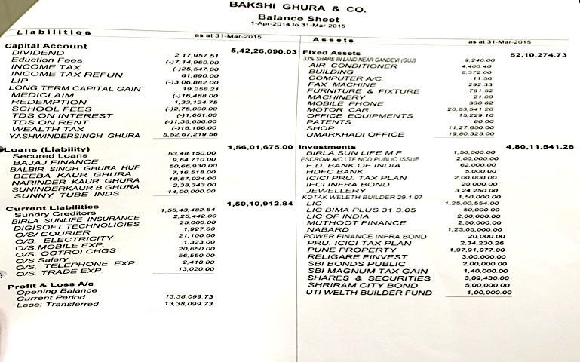**Appendix 3.1 Balance Sheet for the year ended March 31st 2015**.

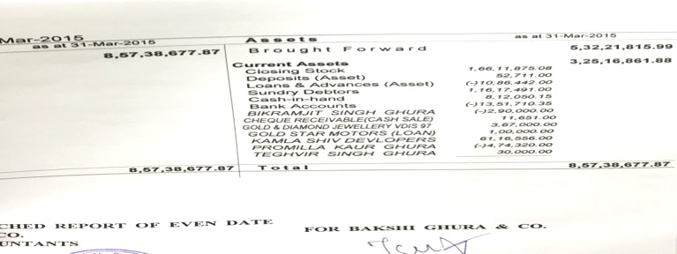

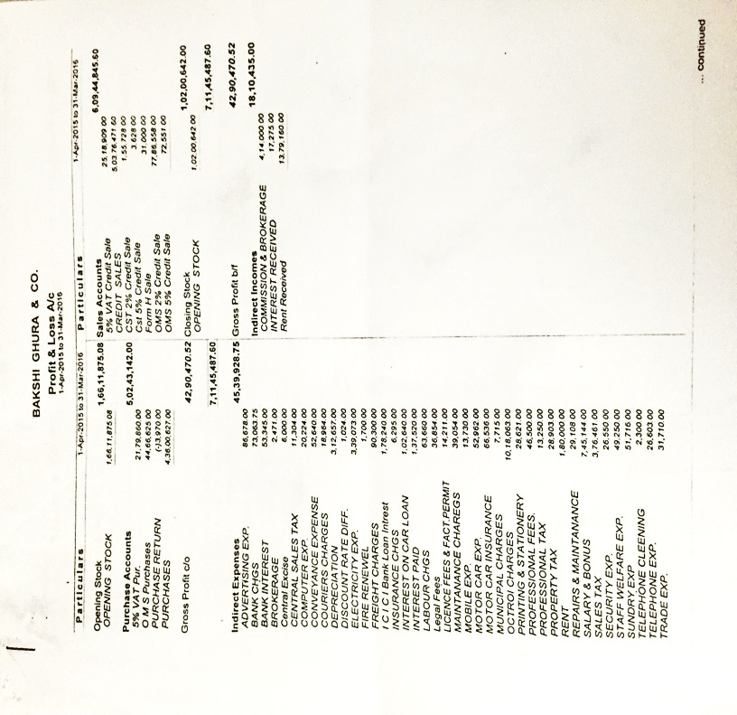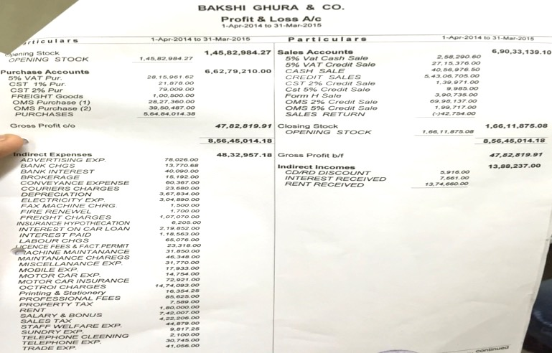**Appendix 3.2 Profit & Loss Account for the year ended 31st March 2015**

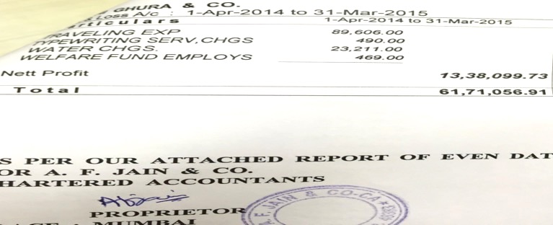

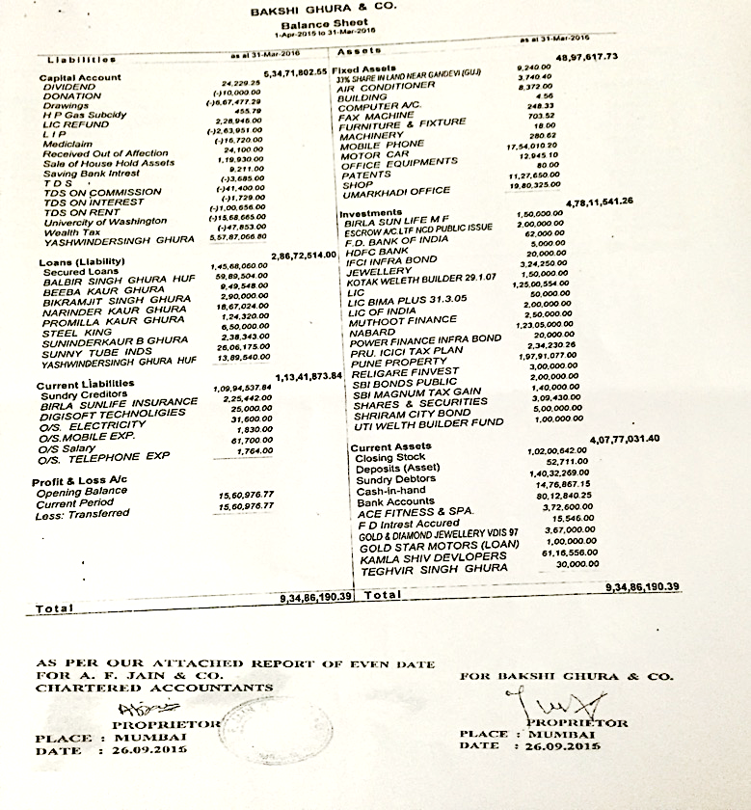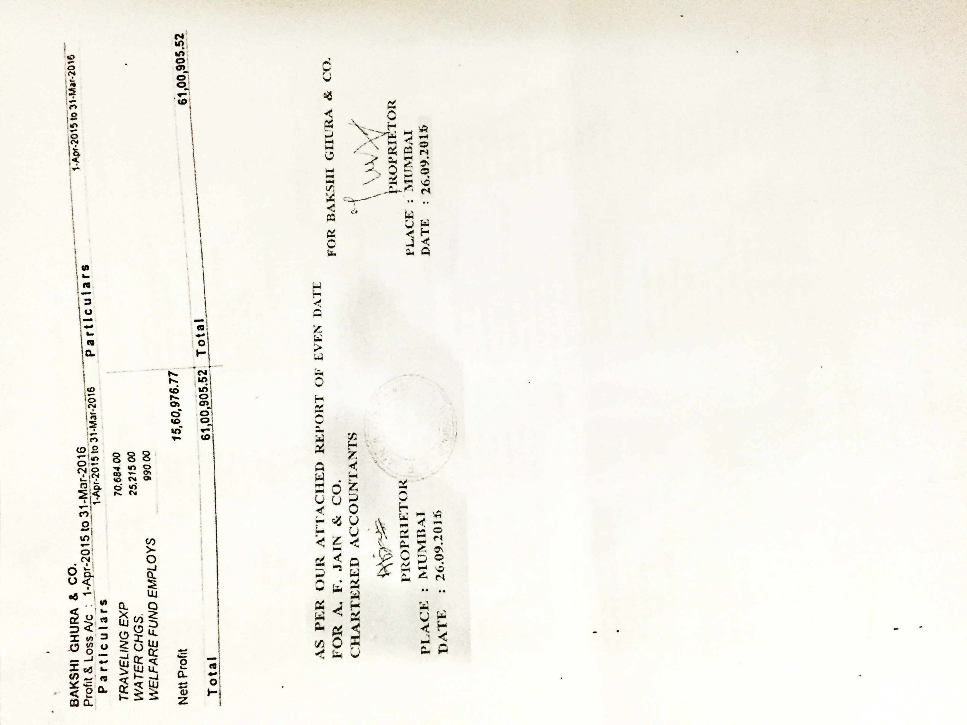**Appendix 3.3 Balance Sheet for the year ended March 31st 2016.**

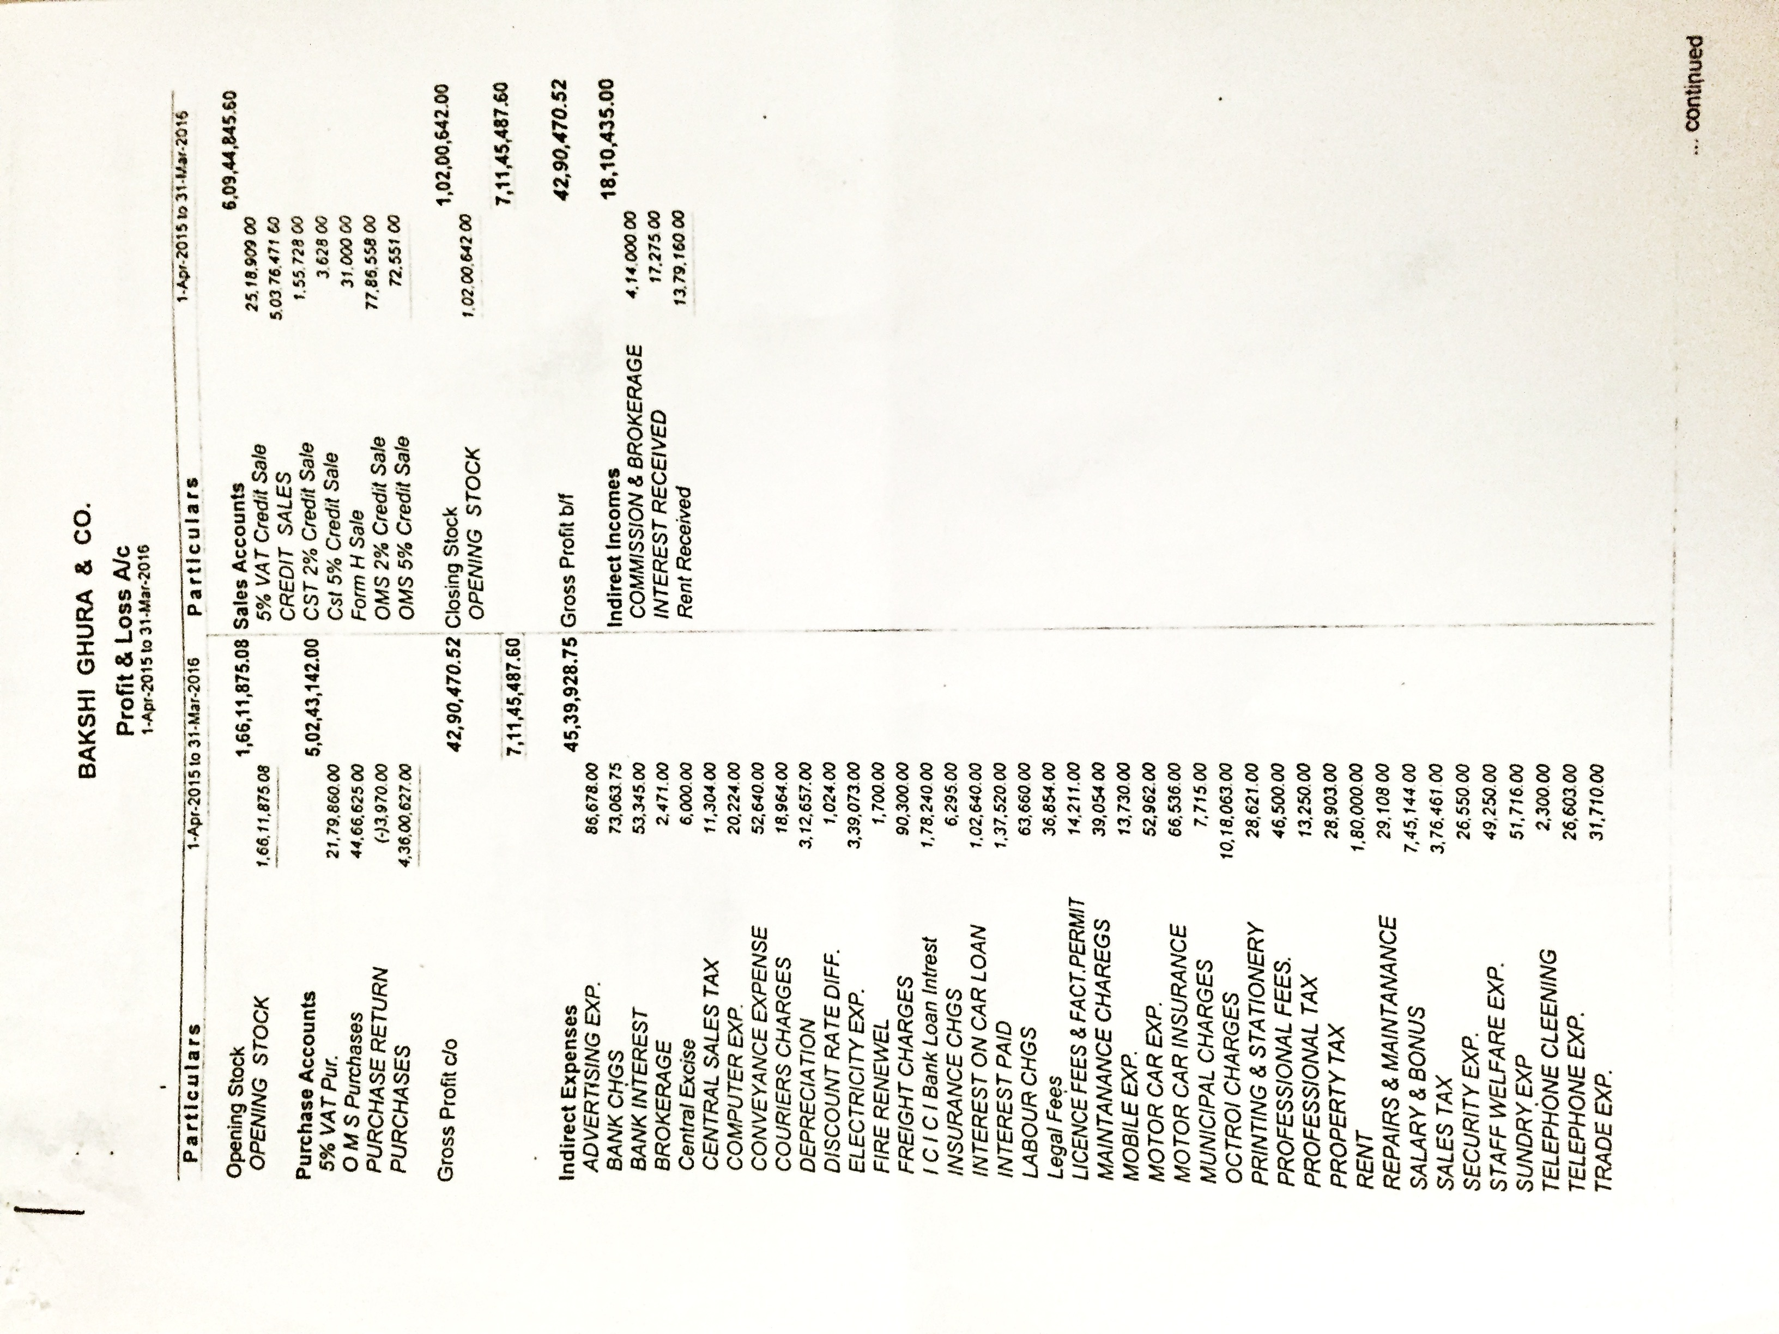**Appendix 3.4 Profit & Loss Account for the year ended 31st March 2016**.

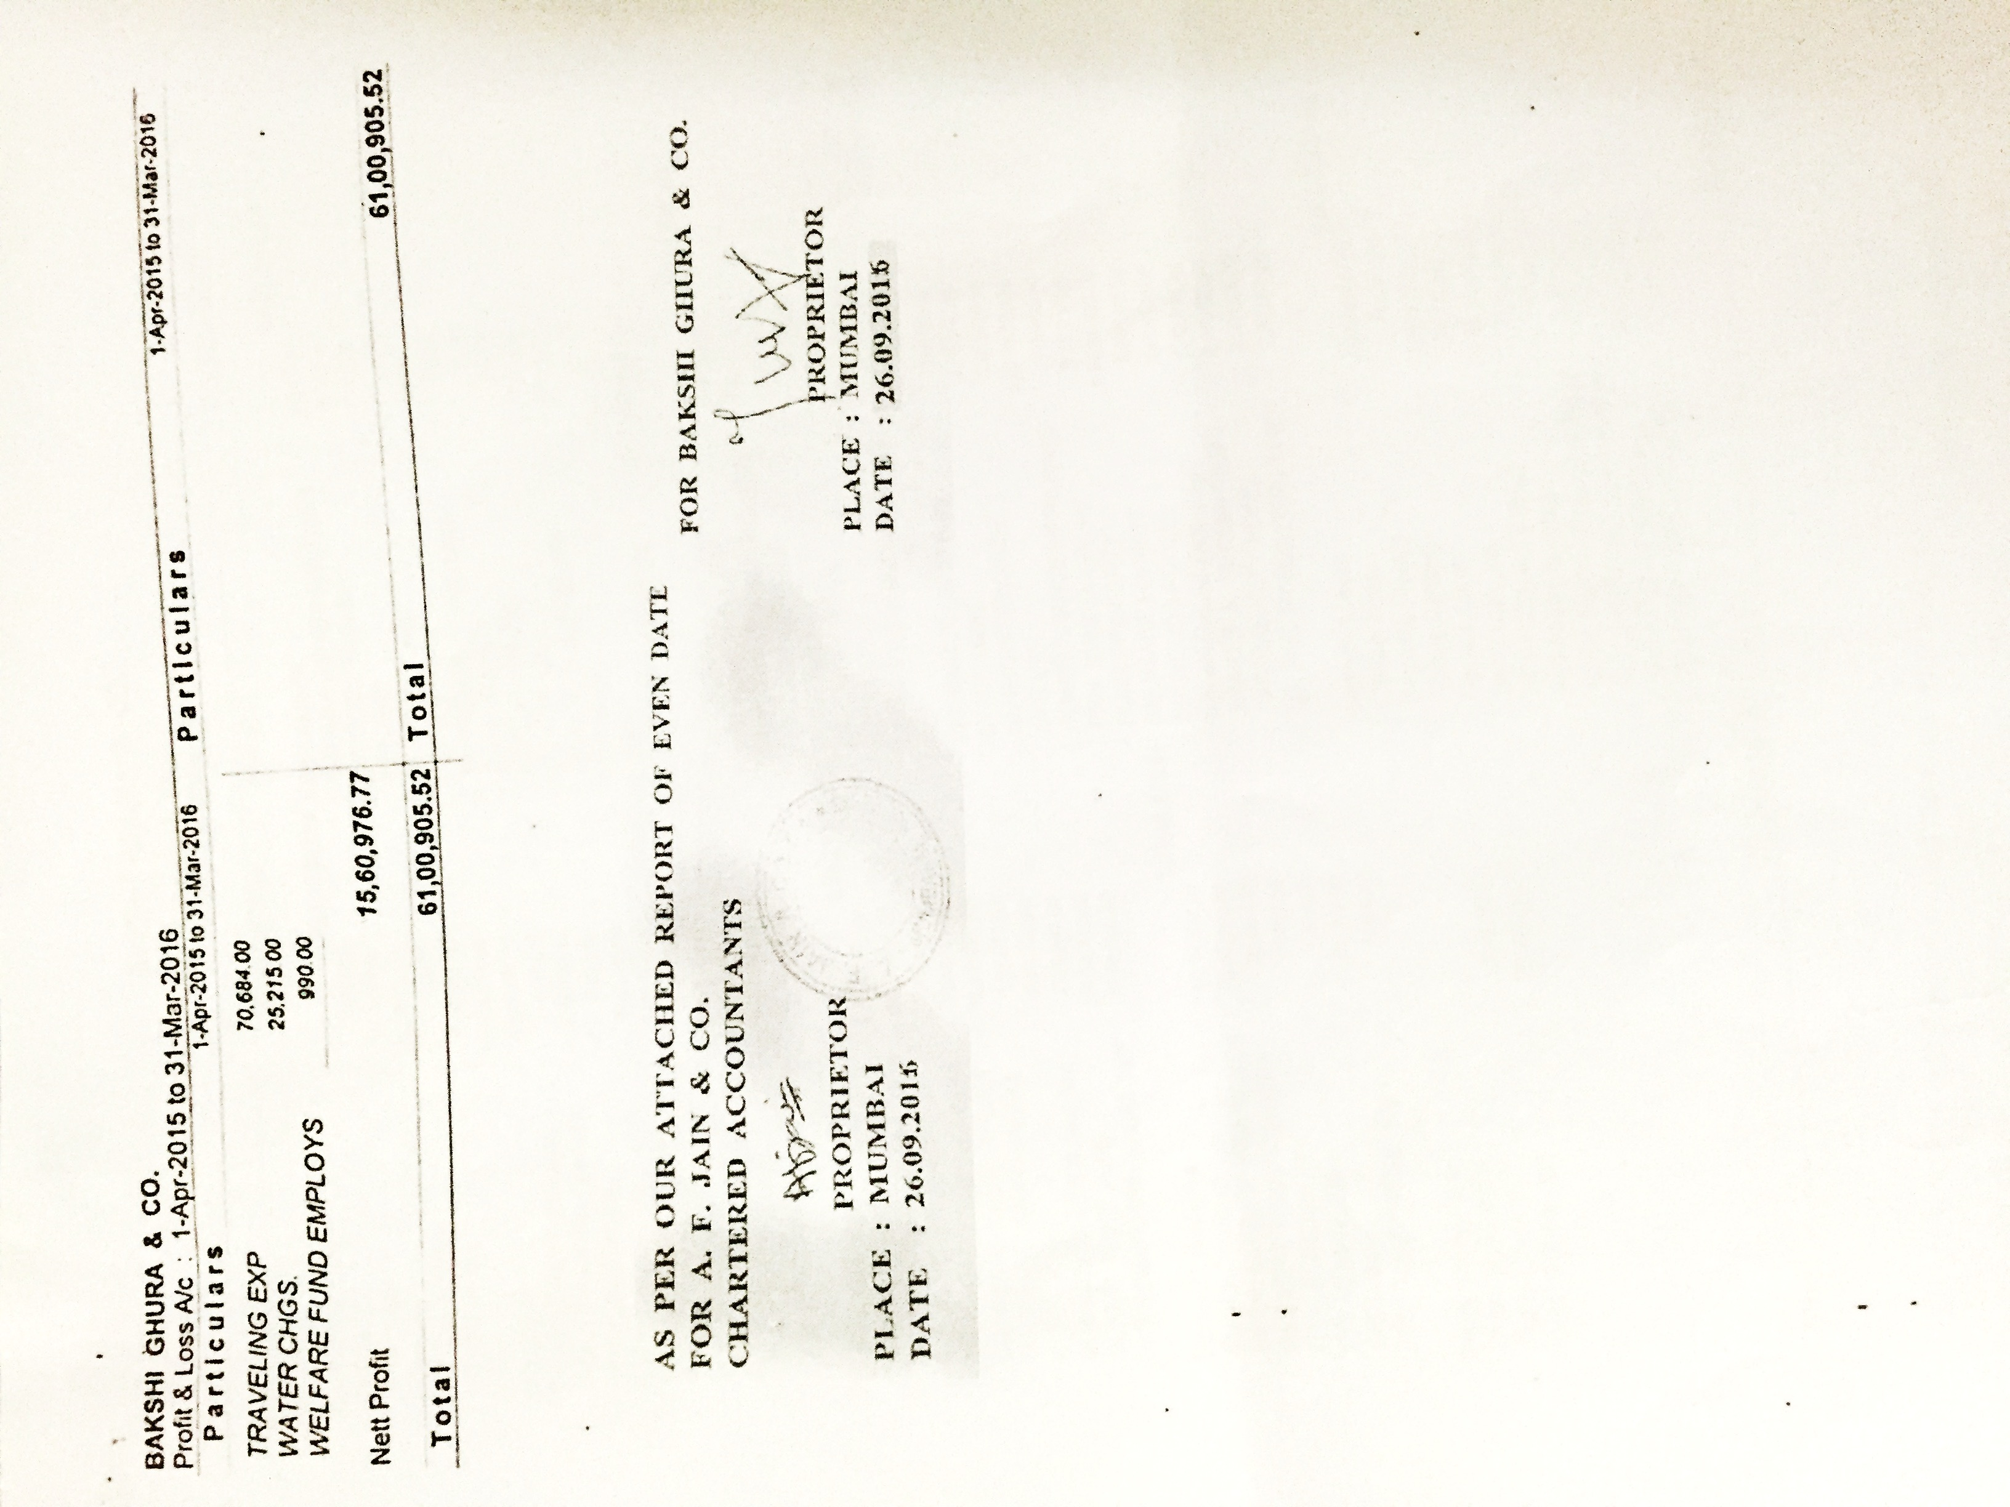

**Appendix 4: Survey/Questionnaire for the customers.**

*This survey is meant solely for my school project. All of your answers will remain anonymous and your names will not be recorded anywhere. Therefore, please answer the questions honestly.*

1. How would you describe the quality of our pipes sold?

* Excellent
* Good
* Moderate
* Poor

1. How would you describe the current price of our pipes?

* High
* Moderate
* Low

1. Are you given a discount or incentive to buy our pipes?

* Always
* Often
* Seldom
* Never

1. When our pipes are bought on credit, is the credit period sufficient for you?

* Yes
* Maybe
* No

1. How would you describe the quality of pipes of our competitors?

* Excellent
* Good
* Moderate
* Poor

1. How would you describe the current price of pipes of our competitors?

* High
* Moderate
* Low

1. Are you given a discount or incentive to buy our competitors pipes?

* Always
* Often
* Seldom
* Never

1. i. When competitor pipes are bought on credit, is the credit period sufficient for you?

* Yes
* Maybe
* No

ii. How does their credit period compare to that of Bakshi Ghura & Co.?

* Longer credit period
* Shorter credit period
* Equivalent credit period

1. i. How many times do you choose to purchase pipes from us rather than from our competitors?

* Always
* Mostly
* Often
* Rarely

ii. Why? (Circle the one that is most important in your perspective.)

* Lower price of pipes
* Better quality of pipes
* More trust or loyalty
* Bargaining power
* Longer credit period facility

**Appendix 5: Survey/Questionnaire for customers translated in Hindi.**

*यह सर्वेक्षण सिर्फ़ और सिर्फ़ मेरे विद्यालय के लिए पूरी तरह से मतलब हैं। आपके सारे जवाब अनाम रहेंगे और आपके नाम कही नहीं दर्ज कीए जाएँगे। इसलिए, ईमानदारी से सारे सवालों का जवाब दें।*

१. आप हमारे पाइपों की गुणवत्ता को कैसे परिभाषित करेंगे?

* अत्युत्तम
* अच्छी
* मध्यम
* बुरी

२. आप हमारे पाइपों की मौजूदा क़ीमत को कैसे परिभाषित करेंगे?

* ऊँची
* मध्यम
* नीच

३. हमारे पाइप ख़रीदने के लिए, क्या आपको छूट या प्रोत्साहन दिया जाता है?

* हमेशा
* अक्सर
* कभी-कभी
* कभी नहीं

४. जब आप हमारे पाइप क्रेडिट पे ख़रीदते है, तो क्या आप के लिए ऋण की अवधि के लिए पर्याप्त समय होता हैं?

* हाँ
* शायद
* नहीं

५. आप हमारे प्रतिद्वंद्वियों के पाइपों के गुणवत्ता को कैसे परिभाषित करेंगे?

* अत्युत्तम
* अच्छी
* मध्यम
* बुरी

६. आप हमारे प्रतिद्वंद्वियों के पाइपों की मौजूदा क़ीमत को कैसे परिभाषित करेंगे?

* ऊँची
* मध्यम
* नीच

७. हमारे प्रतिद्वंद्वियों के पाइप ख़रीदने के लिए, क्या आपको छूट या प्रोत्साहन दिया जाता है?

* हमेशा
* अक्सर
* कभी-कभी
* कभी नहीं

८. i. जब प्रतिद्वंद्वियों के पाइप आप ख़रीदते हो, तो आप के लिए ऋण की अवधि पर्याप्त है?

* हाँ
* शायद
* नहीं

ii. उनकी ऋण अवधि की तुलना में, बक्शी घुरा एंड को. की कैसी ऋण अवधि है?

* ज़्यादा समय
* कम समय
* समान समय

९. i. आप कितनी बार चयन करते है की पाइप प्रतिद्वंद्वियों के बजाय हमसे खरीदोगे?

* हमेशा
* अधिकतर
* अक्सर
* बहुत कम

ii. क्यूँ?

* पाइपों की कम क़ीमत
* पाइपों की बेहतर गुणवत्ता
* ज़्यादा भरोसा
* सौदेबाजी की शक्ति
* ज़्यादा लम्बी ऋण की अवधि

1. Ghura, Bakshi, Mr. "Interview with the Owner (Mr. Bakshi Ghura)." Personal interview. 15 June 2016.
2. Ghura, Bakshi, Mr. "Interview with the Owner (Mr. Bakshi Ghura)." Personal interview. 15 June 2016.
3. Shinde, Deepak, Mr. "Interview with the Senior Manager (Mr. Deepak Shinde)." Personal interview. 15 June 2016.
4. Ghura, Bakshi, Mr. "Interview with the Owner (Mr. Bakshi Ghura)." Personal interview. 15 June 2016.
5. Ghura, Bakshi, Mr. "Interview with the Owner (Mr. Bakshi Ghura)." Personal interview. 15 June 2016.
6. Ghura, Bakshi, Mr. "Interview with the Owner (Mr. Bakshi Ghura)." Personal interview. 15 June 2016.
7. Kelkar, Neeta, Mrs. "Interview conducted with the Financial Accountant (Mrs. Neeta Kelkar)." Personal interview. 15 June 2016.
8. Shinde, Deepak, Mr. "Interview with the Senior Manager (Mr. Deepak Shinde)." Personal interview. 15 June 2016.
9. Ghura, Bakshi, Mr. "Interview with the Owner (Mr. Bakshi Ghura)." Personal interview. 15 June 2016.
10. Ghura, Bakshi, Mr. "Interview with the Owner (Mr. Bakshi Ghura)." Personal interview. 15 June 2016.
11. Shinde, Deepak, Mr. "Interview with the Senior Manager (Mr. Deepak Shinde)." Personal interview. 15 June 2016.
12. Hoang, Paul. *International baccalaureate business and management*. Place of publication not identified: Ibid Press, 2014. Print.
13. Hoang, Paul. *International baccalaureate business and management*. Place of publication not identified: Ibid Press, 2014. Print.
14. Hoang, Paul. *International baccalaureate business and management*. Place of publication not identified: Ibid Press, 2014. Print.
15. Hoang, Paul. *International baccalaureate business and management*. Place of publication not identified: Ibid Press, 2014. Print.
16. "Survey/Questionnaire for the customers." Personal interview. 15 June 2016.
17. "Survey/Questionnaire for the customers." Personal interview. 15 June 2016.
18. "Survey/Questionnaire for the customers." Personal interview. 15 June 2016.
19. "Survey/Questionnaire for the customers." Personal interview. 15 June 2016.
20. "Survey/Questionnaire for the customers." Personal interview. 15 June 2016.
21. "Survey/Questionnaire for the customers." Personal interview. 15 June 2016.
22. Root. "SWOT Analysis." *Investopedia*. N.p., 13 Oct. 2015. Web. 30 Sept. 2017.
23. Hoang, Paul. *International baccalaureate business and management*. Place of publication not identified: Ibid Press, 2014. Print.
24. Figure 1 and 2: Customer survey on the quality of pipes of Bakshi Ghura & Co. vs Competitors
25. Ghura, Bakshi, Mr. "Interview with the Owner (Mr. Bakshi Ghura)." Interview. 20 June 2016: n. pag. Web. 20 June 2016.